Single-Cell Transcriptomic Dissection of Immune and Epithelial Remodeling Across the Normal Cervix–HSIL–Carcinoma Continuum
Mifty SK¹, Lamia JS², Sujana SA³
¹Dhaka Medical College and Hospital (DMCH), Dhaka, Bangladesh.
²Sylhet Agricultural University, Sylhet
³Independent University, Bangladesh

Graphical Abstract

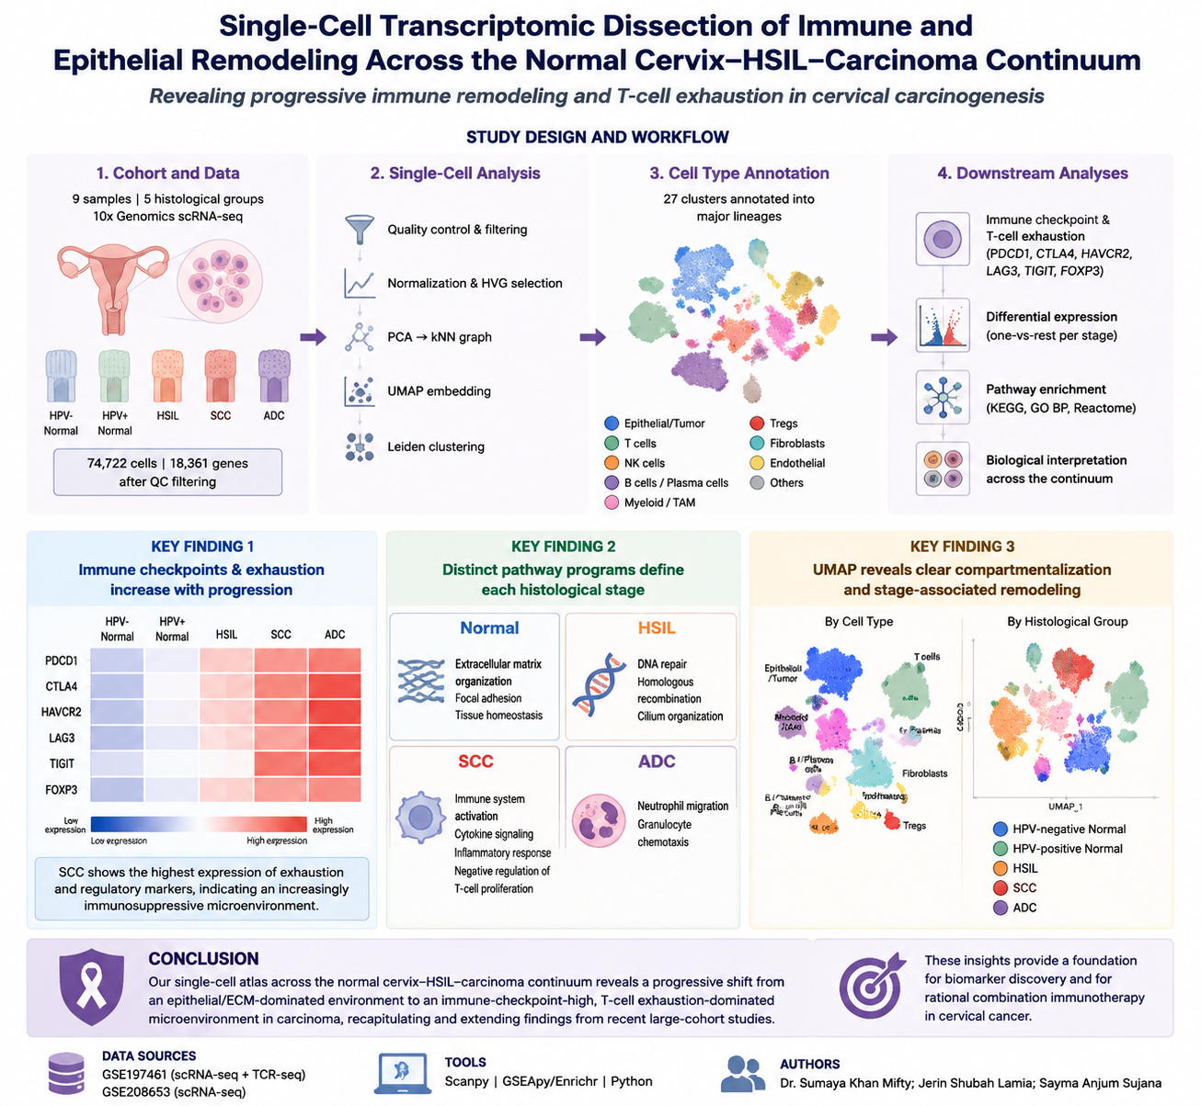

Table of Contents
No. | Section | Page
 | Graphical Abstract | 1
 | Table of Contents | 2
 | Abstract | 4
 | Keywords | 4
1 | Introduction | 5
2 | Materials and Methods | 6
2.1 | Data Retrieval and Sample Composition | 6
2.2 | Quality Control (QC) and Filtering | 6
2.3 | Normalization, Feature Selection, Dimensionality Reduction and Clustering | 8
2.4 | Dimensionality Reduction and Graph-Based Clustering | 8
2.5 | Tumor Microenvironment Cell Type Annotation | 9
2.6 | Evaluation of T-Cell Exhaustion and Immune Checkpoint Expression | 9
2.7 | Differential Gene Expression Analysis | 10
2.8 | Over-Representation Analysis (Pathway Enrichment) | 12
2.9 | Environment and Reproducibility | 12
3 | Results | 12
3.1 | Cohort Composition and Quality Control | 12
3.2 | UMAP Embeddings Showing Clusters and Tissue Group Distribution | 13
3.3 | Cell Lineage Dotplot/Feature Plots Establishing Cell-Type Identities | 14
3.4 | Stage-Resolved Differential Gene Expression Analysis | 17
3.5 | Immune-Checkpoint / T-Cell Exhaustion Transcripts Escalate Toward Carcinoma | 19
3.6 | Genes Displayed: Six Well-Established Markers of T-Cell Exhaustion and Regulatory Activity | 20
3.7 | Pathway Enrichment Reveals Stage-Specific Functional Programs | 20
4 | Discussion | 23
5 | Limitations | 24
6 | Conclusion | 24
7 | References | 25
8 | Declaration of AI Tool Usage | 25
9 | Author Contribution | 26

List of Figures

Figure No. | Figure Title | Page
Graphical Abstract | Study workflow and major findings of cervical cancer immune remodeling analysis | 1
Figure 1 | Selection of Highly Variable Genes During Single-Cell RNA-seq Preprocessing | 8
Figure 2 | Principal Component Contribution Analysis for Dimensionality Reduction | 9
Figure 3 | Quality-Control Metrics Across the Cervical Neoplastic Continuum | 13
Figure 4 | UMAP Embedding of 74,722 Cervical Cells Showing Leiden Clusters and Tissue Distribution | 14
Figure 5a | Marker-Gene Dot Plot Across Leiden Clusters for Major Cervical Tissue Lineages | 16
Figure 5b | UMAP Feature Plots of Representative Marker Genes for Major Lineages | 17
Figure 6 | Expression of T-Cell Exhaustion and Immune-Checkpoint Genes Across the Cervical Neoplastic Continuum | 20
Figure 7 | Stage-Specific Pathway Enrichment Analysis Reveals Progressive Remodeling of the Cervical Tumor Microenvironment | 21

List of Tables

Table No. | Table Title | Page
Table 1 | Raw Data Acquisition and Sample Structure | 6
Table 2 | Sample Information Used for Single-Cell Analysis | 6
Table 3 | Sample Composition and Post-QC Cell Yield per Histological Group | 12
Table 4 | Representative Top One-vs-Rest Differentially Expressed Genes per Histological Stage | 18
Table 5 | Log2 Fold-Change of Six Immune-Checkpoint/Exhaustion Transcripts Across Histological Stages | 19
Table 6 | Six Well-Established Markers of T-Cell Exhaustion and Regulatory Activity | 20
Table 7 | Top Enriched Terms per Stage Across KEGG, GO-BP and Reactome Libraries | 22

Abstract

Background. Persistent high-risk human papillomavirus (HPV) infection drives a stepwise transition from normal cervical epithelium through high-grade squamous intraepithelial lesions (HSIL) to invasive carcinoma, a process accompanied by progressive remodeling of the tumor immune microenvironment (TIME). Single-cell RNA sequencing (scRNA-seq) offers cell-resolved insight into this transition that is unavailable from bulk profiling.
Aim. To reconstruct the single-cell transcriptional landscape of the normal cervix–HSIL–carcinoma continuum from public 10x Genomics data and to characterize stage-associated shifts in immune-checkpoint/exhaustion transcripts and functional pathway activity, benchmarked against two published reference atlases of the cervical tumor microenvironment.
Methods. Raw count matrices from nine 10x Genomics samples spanning five histological groups (HPV-negative normal, HPV-positive normal, precancerous HSIL, squamous cell carcinoma [SCC], and adenocarcinoma [ADC]) were merged, quality-filtered, log-normalized and processed in Scanpy (PCA → k-NN graph → UMAP → Leiden clustering). Nine canonical lineage marker panels were used to annotate cluster identity. One-vs-rest differential expression (Wilcoxon rank-sum) was computed per histological stage, and stage-specific up-regulated gene sets (log2FC>1, adjusted P<0.01) were tested for over-representation against KEGG, GO-Biological Process and Reactome using GSEApy.
Results. After filtering, 74,722 cells and 18,361 genes across five histological groups were retained and resolved into 27 unsupervised clusters, with UMAP space cleanly separating epithelial, T/NK, myeloid, B/plasma, fibroblast and endothelial compartments. The canonical exhaustion/immune-checkpoint transcripts HAVCR2, TIGIT, LAG3, CTLA4 and FOXP3 were all significantly enriched in SCC relative to the rest of the cohort (log2FC 0.79–1.80, adjusted P as low as 2.5×10 ), while the same transcripts were significantly depleted in the Normal and HSIL groups – a pattern consistent with progressive T-cell exhaustion and regulatory T-cell accumulation toward malignancy. Pathway enrichment of SCC-elevated genes was dominated by innate/adaptive immune and cytokine-signaling programs (Reactome Immune System, GO Inflammatory Response, negative regulation of T-cell proliferation), whereas the Normal group was enriched for extracellular-matrix organization and focal-adhesion programs, and HSIL for DNA-repair/homologous-recombination and ciliary-assembly programs.
123
Conclusion. This independent re-analysis reproduces, at the transcript level, the central immune-escalation narrative reported in large-cohort cervical cancer single-cell atlases: a shift from an epithelial-homeostatic, ECM-organizing normal cervix toward an immune-checkpoint-high, exhaustion-dominated microenvironment in carcinoma. The pipeline and its outputs are provided as a reusable, version-controlled resource for further sub-clustering of the immune compartment.

Keywords: cervical cancer; single-cell RNA sequencing; HPV; tumor microenvironment; T-cell exhaustion; Scanpy; pathway enrichment

Introduction
Cervical cancer remains the fourth most common malignancy in women worldwide, and its development is causally linked to persistent infection with high-risk human papillomavirus (HPV), most commonly HPV-16/18. Progression follows a
well-defined histological sequence – normal squamous epithelium → high-grade squamous intraepithelial lesion (HSIL) → invasive squamous cell carcinoma (SCC) or adenocarcinoma (ADC) – that is accompanied not only by cell-intrinsic oncogenic transformation (E6/E7-driven cell-cycle deregulation) but also by profound remodeling of the local tumor immune microenvironment (TIME), including infiltration of exhausted CD8⁺ T cells, regulatory T cells (Tregs) and tumor-associated macrophages (TAMs) [1,2]. Two recent single-cell/spatial studies from the same research group provide the reference framework for this project. Guo et al. integrated scRNA-seq and spatial transcriptomics across nine patients spanning HPV-negative normal cervix HPV-positive normal cervix, HSIL and cervical cancer, identifying three stage-specific “HPV-related” epithelial clusters and describing a gradual immune transition from activation to dysregulation and, ultimately, exhaustion as disease escalates [1]. Qu et al. subsequently profiled 17 cervical specimens and showed that malignant cervical epithelial cells themselves show little evidence of classical immune escape (no MHC-I loss, no widespread checkpoint-ligand up-regulation), and instead identified a mature, IDO1-expressing LAMP3⁺ dendritic-cell population that synergistically engages CD8⁺ exhausted T cells and CD4⁺ regulatory T cells to drive immune suppression, a mechanism that could be targeted pharmacologically together with checkpoint blockade [2]. The present project uses the raw 10x Genomics count matrices distributed with the course materials – nine samples spanning the same five histological groups used in [1] – to independently reconstruct this normal–HSIL–carcinoma continuum with a standard Scanpy workflow, and to ask whether an entry-level, single-package analysis (without spatial transcriptomics, TCR-seq or CellPhoneDB ligand–receptor modeling) recovers the same qualitative signal: increasing immune-checkpoint/exhaustion transcript burden and a shift in dominant biological pathways as tissue progresses toward malignancy. All code, intermediate tables and figures referenced below are available in the accompanying GitHub repository.

Materials and Methods

Data Retrieval and Sample Composition
Raw 10x Genomics count matrices were obtained from publicly available cervical cancer single-cell transcriptomic datasets (GSE197461 and GSE208653). Nine samples representing five clinically relevant stages of cervical carcinogenesis were selected, including HPV-negative normal cervix, HPV-positive normal cervix, HSIL precancerous lesions, cervical squamous cell carcinoma (SCC), and cervical adenocarcinoma (ADC). Each sample was processed individually and integrated into a unified AnnData object for downstream analysis.

Table 1. Raw Data Acquisition and Sample Structure
Category | Description
Data source | Publicly available single-cell RNA sequencing datasets obtained from GEO
Reference datasets | Guo et al. (2023) cervical cancer atlas and Qu et al. (2023) cervical cancer single-cell dataset
GEO accession numbers | GSE197461 (scRNA-seq + TCR-seq) and GSE208653 (scRNA-seq)
Data type analyzed | 10x Genomics single-cell RNA sequencing count matrices
Raw data format | Standard 10x Genomics output files: barcodes.tsv.gz, features.tsv.gz, and matrix.mtx.gz
Data loading method | Individual samples were imported into Scanpy using sc.read_10x_mtx() with gene symbols assigned as variable names
Number of samples analyzed | 9 samples
Clinical stages represented | Five biological stages of cervical carcinogenesis
Total cells before quality control | 83,959 cells
Total genes detected | 20,615 genes
Data integration approach | Individual AnnData objects were concatenated using ad.concat() with an outer gene join to generate a unified single-cell dataset
Metadata annotation | Each cell was annotated with sample identity, clinical group, and tissue classification (normal, pre-cancer, tumor)
Biological framework | Sample selection followed the HPV-associated cervical carcinogenesis continuum described by Guo et al. (2023)

Table 2. Sample Information Used for Single-Cell Analysis

Sample ID | Clinical Category | Tissue Classification | Disease Status
N_HPV_NEG_1 | Normal cervix | Normal | HPV-negative
N_HPV_NEG_2 | Normal cervix | Normal | HPV-negative
N_1 | Normal cervix | Normal | HPV-positive
N_2 | Normal cervix | Normal | HPV-positive
HSIL_1 | High-grade squamous intraepithelial lesion | Pre-cancer | Precancerous lesion
HSIL_2 | High-grade squamous intraepithelial lesion | Pre-cancer | Precancerous lesion
SCC_4 | Cervical squamous cell carcinoma | Tumor | Invasive carcinoma
SCC_5 | Cervical squamous cell carcinoma | Tumor | Invasive carcinoma
ADC_6 | Cervical adenocarcinoma | Tumor | Invasive carcinoma

  - Quality Control (QC) & Filtering

Inspection of sample metadata (adata.obs)
The cell-level metadata stored in adata.obs were examined. This table contains information for every cell, including:
- sample – original sample ID
- group – disease stage (Normal_HPV_Neg, Normal_HPV_Pos, Precancerous_HSIL, Cervical_SCC, Cervical_ADC)
- tissue_type – Normal or Tumor
- sample_batch – experimental batch
Result: The dataset contained 83,959 cells before filtering.
Rationale: Correct labeling of every cell with its disease group was verified to ensure that later comparisons between stages are valid.

Annotation of mitochondrial, ribosomal and hemoglobin genes
Special gene groups commonly used for QC were annotated as follows:
- Mitochondrial genes (mt) – gene names starting with “MT-”
- Ribosomal genes (ribo) – gene names starting with “RPS” or “RPL”
- Hemoglobin genes (hb) – gene names starting with HBA, HBB, HBD, HBE, HBG, HBM, HBQ or HBZ
- Code used:
adata.var["mt"] = adata.var_names.str.startswith("MT-")
adata.var["ribo"] = adata.var_names.str.startswith(("RPS", "RPL"))
adata.var["hb"] = adata.var_names.str.startswith(("HBA", "HBB", "HBD", ...))
- Rationale: A high mitochondrial percentage usually indicates dying or stressed cells. A high hemoglobin percentage indicates red-blood-cell contamination. These percentages were therefore calculated for every cell.

Calculation of QC metrics for every cell
The Scanpy function sc.pp.calculate_qc_metrics was used to compute the following metrics:
- n_genes_by_counts – number of genes detected in each cell
- total_counts – total number of UMIs (RNA molecules) in each cell
- pct_counts_mt – percentage of counts derived from mitochondrial genes
- pct_counts_hb – percentage of counts derived from hemoglobin genes
Code used:
sc.pp.calculate_qc_metrics(adata, qc_vars=["mt", "ribo", "hb"],
percent_top=None, log1p=False, inplace=True)
Rationale: These four metrics served as the main criteria for deciding which cells and genes were retained.

Visualization of QC metrics (Violin plots)
The four QC metrics were plotted as violin plots, grouped by disease stage (Normal_HPV_Neg → Normal_HPV_Pos → Precancerous_HSIL → Cervical_SCC → Cervical_ADC). This visualization allowed assessment of whether any disease stage exhibited systematically lower quality.
Key observations:
- Gene counts and total counts were comparable across all groups.
- Mitochondrial percentage remained low in the majority of cells; a modestly higher tail was observed in Cervical_ADC.
- Hemoglobin percentage was negligible in all groups.

Filtering of low-quality cells and genes
Filter criterion | Threshold applied | Purpose
Minimum genes per cell | ≥ 250 genes | Removal of empty droplets / low-complexity cells
Minimum cells per gene | ≥ 5 cells | Removal of genes detected in very few cells
Mitochondrial percentage | < 15 % | Removal of dying / stressed cells
Hemoglobin percentage | < 5 % | Removal of red-blood-cell contamination
Code used:
sc.pp.filter_cells(adata, min_genes=250)
sc.pp.filter_genes(adata, min_cells=5)
adata = adata[adata.obs["pct_counts_mt"] < 15.0, :].copy()
adata = adata[adata.obs["pct_counts_hb"] < 5.0, :].copy()

Outcome after filtering:
- 1,747 cells were removed because fewer than 250 genes were expressed
- 2,254 genes were removed because they were detected in fewer than 5 cells
- 74,722 cells were retained after all QC filters

3. Summary of QC & Filtering
Starting number of cells: 83,959
Cells removed: ~9,237 (low gene count + high MT + high HB)
Cells retained: 74,722 (high-quality cells)
Genes retained: genes detected in ≥ 5 cells
Conclusion: After application of standard QC filters, a large number of high-quality cells with comparable library complexity across all disease stages were retained. This filtered dataset is suitable for downstream clustering, cell-type annotation, and biological comparison of the cervical tumor microenvironment.

Normalization, Dimensionality Reduction and Clustering
Counts were library-size normalized to 10,000 counts/cell and log1p-transformed. The top 2,500 highly variable genes (HVGs) were selected (sc.pp.highly_variable_genes, default flavor) and used for a 50-component PCA. A k-nearest-neighbor graph (n_neighbors=20, 30 principal components) was built and embedded in two dimensions with UMAP. Unsupervised community detection used the Leiden algorithm at resolution 0.8 (igraph flavor, 2 iterations), yielding 27 transcriptionally distinct clusters.
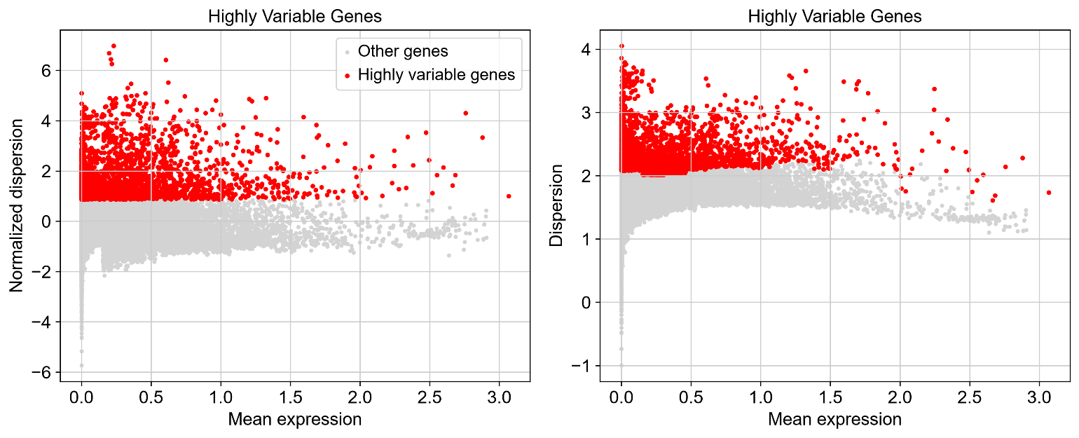
Figure 1. Selection of highly variable genes during single-cell RNA-seq preprocessing.
Scatter plots showing gene-level variability relative to mean expression. Highly variable genes are highlighted in red, whereas remaining genes are shown in grey. The selected highly variable gene set represents genes with increased biological variation across cells and was used for principal component analysis and downstream clustering. This filtering step reduces technical noise while preserving transcriptional features associated with cellular heterogeneity.

Dimensionality Reduction and Graph-Based Clustering (detail)
Principal component analysis (PCA) was performed on the scaled data using the arpack solver. The top 30 principal components were retained for downstream analysis. A k-nearest-neighbor graph was constructed with n_neighbors = 20 and n_pcs = 30. Uniform Manifold Approximation and Projection (UMAP) was then computed to generate a two-dimensional embedding of the cells. Graph-based clustering was performed using the Leiden algorithm at resolution 0.8, resulting in 27 distinct clusters.
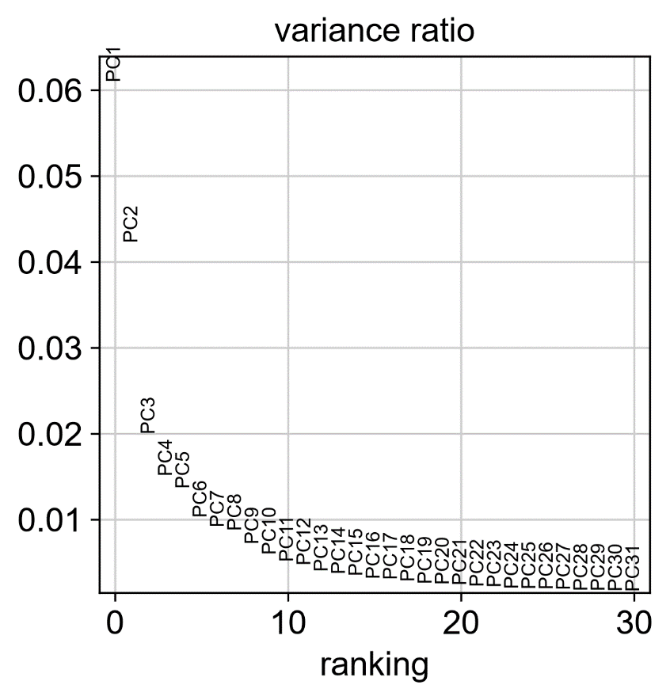
Figure 2. Principal component contribution analysis for dimensionality reduction.
Variance ratio analysis showing the contribution of individual principal components after highly variable gene selection. The first principal components accounted for the largest proportion of transcriptional variance, whereas later components contributed progressively less information. The selected principal components were used to construct the neighborhood graph and perform Leiden clustering followed by UMAP visualization.

Tumor Microenvironment Cell Type Annotatio
Cluster identities were assigned using a nine-lineage canonical marker panel: epithelial/tumor (EPCAM, KRT5, KRT14), T cells (CD3D, CD4, CD8A), regulatory T cells (FOXP3, IL2RA, CTLA4), NK cells (NKG7, NCAM1), B cells (MS4A1, CD79A), plasma cells (SDC1, MZB1), myeloid/TAM (CD14, CD68, CD163), fibroblasts (COL1A1, ACTA2), and endothelial cells (PECAM1, VWF), visualized as a grouped dot plot across the 27 Leiden clusters and as per-gene UMAP feature plots.

  - Evaluation of T-Cell Exhaustion & Immune Checkpoint Expression and Differential Gene Expression Analysis

Selection of exhaustion and checkpoint genes
A curated list of well-established T-cell exhaustion and immune-checkpoint genes was defined:
- PDCD1 (PD-1) – inhibitory receptor, hallmark of exhaustion
- CTLA4 (CTLA-4) – inhibitory receptor, highly expressed on Tregs and exhausted T cells
- HAVCR2 (TIM-3) – marks terminally exhausted T cells
- LAG3 (LAG-3) – co-inhibitory receptor
- TIGIT – co-inhibitory receptor frequently co-expressed with PD-1
- FOXP3 – master transcription factor of regulatory T cells
Only genes present in the dataset were retained for analysis.
Code used:
exhaustion_genes = ["PDCD1", "CTLA4", "HAVCR2", "LAG3", "TIGIT", "FOXP3"]
available_exhaustion = [g for g in exhaustion_genes if g in adata.var_names]
Rationale: These genes are widely used markers of T-cell dysfunction and regulatory activity in the tumor microenvironment. Their coordinated up-regulation is characteristic of T-cell exhaustion and immune suppression in solid tumors, including cervical cancer.

Visualization of exhaustion gene expression across disease stages
Violin plots of the selected exhaustion and checkpoint genes were generated, grouped by disease stage (Normal_HPV_Neg, Normal_HPV_Pos, Precancerous_HSIL, Cervical_SCC, Cervical_ADC).
Code used:
sc.pl.violin(adata, keys=available_exhaustion,
groupby="group", rotation=45, multi_panel=True,
show=False, save="_exhaustion_gene.png")
Rationale: This visualization allows direct comparison of the expression distribution of each exhaustion marker across the neoplastic continuum and helps identify whether exhaustion signatures become more pronounced in invasive stages (SCC and ADC).

Differential Gene Expression Analysis

Preparation of stage labels
For differential expression analysis, the original detailed group labels were mapped to simplified stage categories:
- Normal_HPV_Neg and Normal_HPV_Pos → Normal
- Precancerous_HSIL → HSIL
- Cervical_SCC → SCC
- Cervical_ADC → ADC
The resulting cell numbers per stage were:
- Normal: 40,104 cells
- HSIL: 12,484 cells
- SCC: 14,586 cells
- ADC: 7,548 cells
Rationale: Simplified stage labels facilitate clear biological interpretation of differentially expressed genes along the progression from normal epithelium to invasive carcinoma.

Differential expression across all stages
Differential expression analysis was performed using the Wilcoxon rank-sum test implemented in Scanpy (sc.tl.rank_genes_groups). Genes were ranked for each stage relative to all other stages.
Code used:
sc.tl.rank_genes_groups(adata_stage, groupby="stage",
method="wilcoxon", pts=True)
# Results were extracted for each stage and saved as CSV files
For each stage (Normal, HSIL, SCC, ADC), a table of ranked genes was generated containing:
- Gene names
- Scores and log-fold changes
- Raw and adjusted p-values
- Percentage of cells expressing the gene in the group
Rationale: The Wilcoxon rank-sum test is a robust non-parametric method widely used in single-cell differential expression analysis. It identifies genes that are significantly enriched or depleted in each disease stage.

Differential expression between SCC and Normal tissue
A focused comparison was performed between Cervical_SCC and Normal_HPV_Neg cells using the Wilcoxon rank-sum test, with Normal_HPV_Neg set as the reference group.
Code used:
sc.tl.rank_genes_groups(scc_normal, groupby="group",
groups=["Cervical_SCC"], reference="Normal_HPV_Neg",
method="wilcoxon", pts=True)
The top differentially expressed genes in SCC relative to Normal included multiple interferon-stimulated genes and immune-related genes (e.g., C15orf48, TNFAIP3, STAT1, IFI6, GBP1, ISG15, CCL4, etc.).
Rationale: Direct comparison of invasive squamous cell carcinoma with normal epithelium identifies transcriptional changes specifically associated with malignant transformation and the tumor immune microenvironment.

4. Summary of Analyses Performed
Analysis | Purpose
Exhaustion gene violin plots | Visual comparison of PDCD1, CTLA4, HAVCR2, LAG3, TIGIT, FOXP3 across stages
Stage-wise differential expression | Identification of genes enriched in Normal, HSIL, SCC or ADC
SCC vs Normal DE analysis | Identification of genes specifically altered in invasive SCC
Conclusion: The analyses described above enable systematic evaluation of T-cell exhaustion programs and stage-specific transcriptional changes in the HPV-driven cervical tumor microenvironment. Results from these analyses can be used to support biological interpretation of immune suppression and to identify potential immunotherapy targets.

Over-representation (Pathway Enrichment) Analysis
For each stage, genes significantly up-regulated relative to the rest of the cohort (log2 fold-change > 1 and Benjamini–Hochberg adjusted P < 0.01) were submitted to Enrichr via GSEApy against three gene-set libraries – KEGG_2021_Human, GO_Biological_Process_2023 and Reactome_2022 – and the top-ranked terms (by adjusted P-value) were compared across stages.

Environment and Reproducibility
The analysis environment was managed with uv (Python 3.11) with core packages scanpy, anndata, pandas, numpy, scipy, matplotlib, seaborn and gseapy pinned in requirements.txt/uv.lock for exact reproducibility. All code is provided as a single executed Jupyter notebook (notebooks/complete_notebook.ipynb) together with the exported figures, DE tables and enrichment tables used to build this report.

Results

Cohort Composition and Quality Control
Table 3 summarizes the number of cells retained per histological group after QC filtering. HPV-positive normal cervix contributed the largest number of high-quality cells (n=21,151), followed by HPV-negative normal cervix (n=18,953), SCC (n=14,586), HSIL (n=12,484) and ADC (n=7,548); the ADC group, represented by a single patient (ADC_6), was consistently the smallest and noisiest group throughout the analysis (see Section 5). Per-group QC-metric distributions (Figure 3) show broadly comparable genes/cell and total-count distributions across groups, with the ADC sample showing a visibly heavier tail of %mitochondrial content, consistent with a single-sample batch effect rather than a biological difference.

Group | Samples | Cells (post-QC)
Normal (HPV-negative) | N_HPV_NEG_1, N_HPV_NEG_2 | 18,953
Normal (HPV-positive) | N_1, N_2 | 21,151
Precancerous HSIL | HSIL_1, HSIL_2 | 12,484
Cervical SCC | SCC_4, SCC_5 | 14,586
Cervical ADC | ADC_6 | 7,548
Total (post-QC) | 9 samples | 74,722
Table 3. Sample composition and post-QC cell yield per histological group (min. 250 genes/cell, <15% mitochondrial reads, <5% hemoglobin reads, genes detected in ≥5 cells).

FIGURE 1: Quality Control (QC) Metrics – Violin Plots
SIMPLE SUMMARY
This figure checks whether the single-cell data quality is similar across all sample types
(Normal → HPV+ → HSIL → SCC → ADC). Good quality data = reliable biological results.

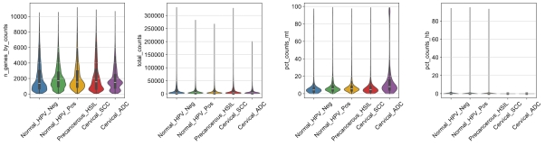
Figure 3. Quality-control metrics across the cervical neoplastic continuum.
Violin plots show number of genes detected (n_genes_by_counts), total UMI counts (total_counts), percentage of mitochondrial counts (pct_counts_mt), and percentage of hemoglobin counts (pct_counts_hb) in cells from Normal_HPV_Neg, Normal_HPV_Pos, Precancerous_HSIL, Cervical_SCC and Cervical_ADC samples. Cellular complexity is comparable across stages. Mitochondrial content remains low in most cells, with a modest increase in the high-mitochondrial tail in adenocarcinoma. Hemoglobin contamination is negligible. These results confirm that technical quality is uniform and suitable for biological comparisons of the tumor microenvironment.

UMAP embeddings showing clusters and tissue group distribution
UMAP embedding of the 74,722 post-QC cells showed a clear separation of the major cellular lineages and gradual compositional changes across disease stages: (1) Leiden clustering (resolution 0.8) found 27 clusters. (2) In the clinical group coloring, Normal_HPV_Neg and Normal_HPV_Pos samples largely overlapped, whereas Cervical_SCC and Cervical_ADC samples occupied more distinct regions, indicating disease-associated remodeling. (3) When colored by tissue type (normal / precancer/tumor), a clear progression was observed from normal tissue through HSIL to invasive carcinoma. (4) Individual sample coloring confirmed that the separation was driven primarily by biological differences rather than strong batch effects. The results show that subtle reorganization of the cervical TME occurs during the progression of HPV-driven disease from normal cervix to HSIL and invasive carcinoma.
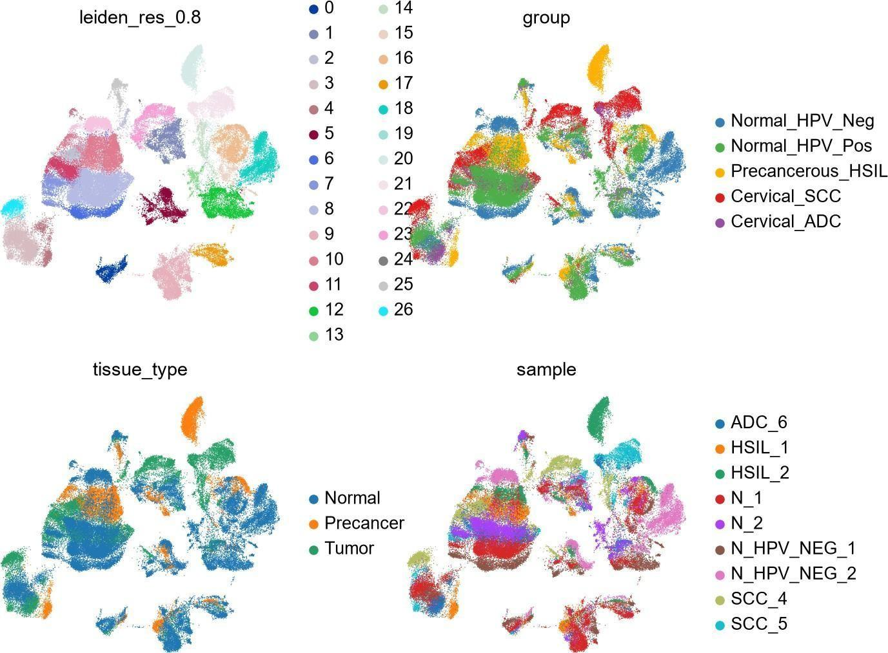
Figure 4. UMAP embedding of 74,722 cervical cells coloured by (top left) 27 unsupervised Leiden clusters (resolution 0.8), (top right) histological group, (bottom left) coarse tissue category (Normal / Precancer / Tumor), and (bottom right) sample of origin.

Cell lineage dotplot/feature plots establishing cell-type identities
Major cellular lineages of the cervical tumor microenvironment were annotated using a nine- lineage canonical marker panel. The group dot plot (Figure 5a) of marker expression across the 27 Leiden clusters cleanly separated the by the expected compartments: Epithelial / Tumor clusters (clusters 0, 12, 13, 15, 16, 18, 19, 20, 21) – high expression of EPCAM, KRT5 and KRT14, T / NK clusters (clusters 1, 2, 6, 7, 8, 10, 11, 22) – high expression of CD3D and/or NKG7, Myeloid / TAM clusters (clusters 1, 23, 24) – high expression of CD14, CD68 and CD163, Plasma-cell dominant clusters (clusters 5, 24) – high expression of SDC1 and MZB1, B-cell cluster (cluster 25) – expression of MS4A1 and CD79A, Fibroblast cluster (cluster 9) – strong
expression of COL1A1, Endothelial cluster (cluster 17) – expression of PECAM1 and VWF. Feature-level UMAP plots for one representative marker per lineage (Figure 5b) confirmed spatially restricted and mutually exclusive expression of EPCAM, CD3D, CD68, MS4A1, COL1A1 and PECAM1, validating cluster identity at single-gene resolution. Regulatory T-cell markers (FOXP3, IL2RA, CTLA4) were diffusely low across all clusters at this resolution, consistent with Tregs forming a rare, state-defined population rather than a discrete transcriptional cluster. Clean recovery of this subset would require dedicated CD4⁺ T-cell sub-clustering, as performed in the reference study by (Qu et al., 2023).
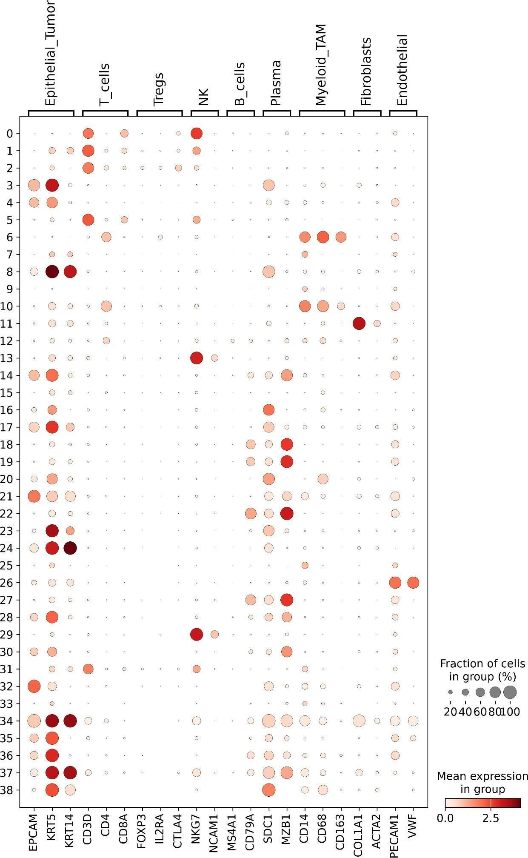
Figure 5a. Marker-gene dot plot across the Leiden clusters (rows) for nine canonical cervical tissue lineages (column groups). Dot size = fraction of cells in the cluster expressing the gene; colour = scaled mean expression.
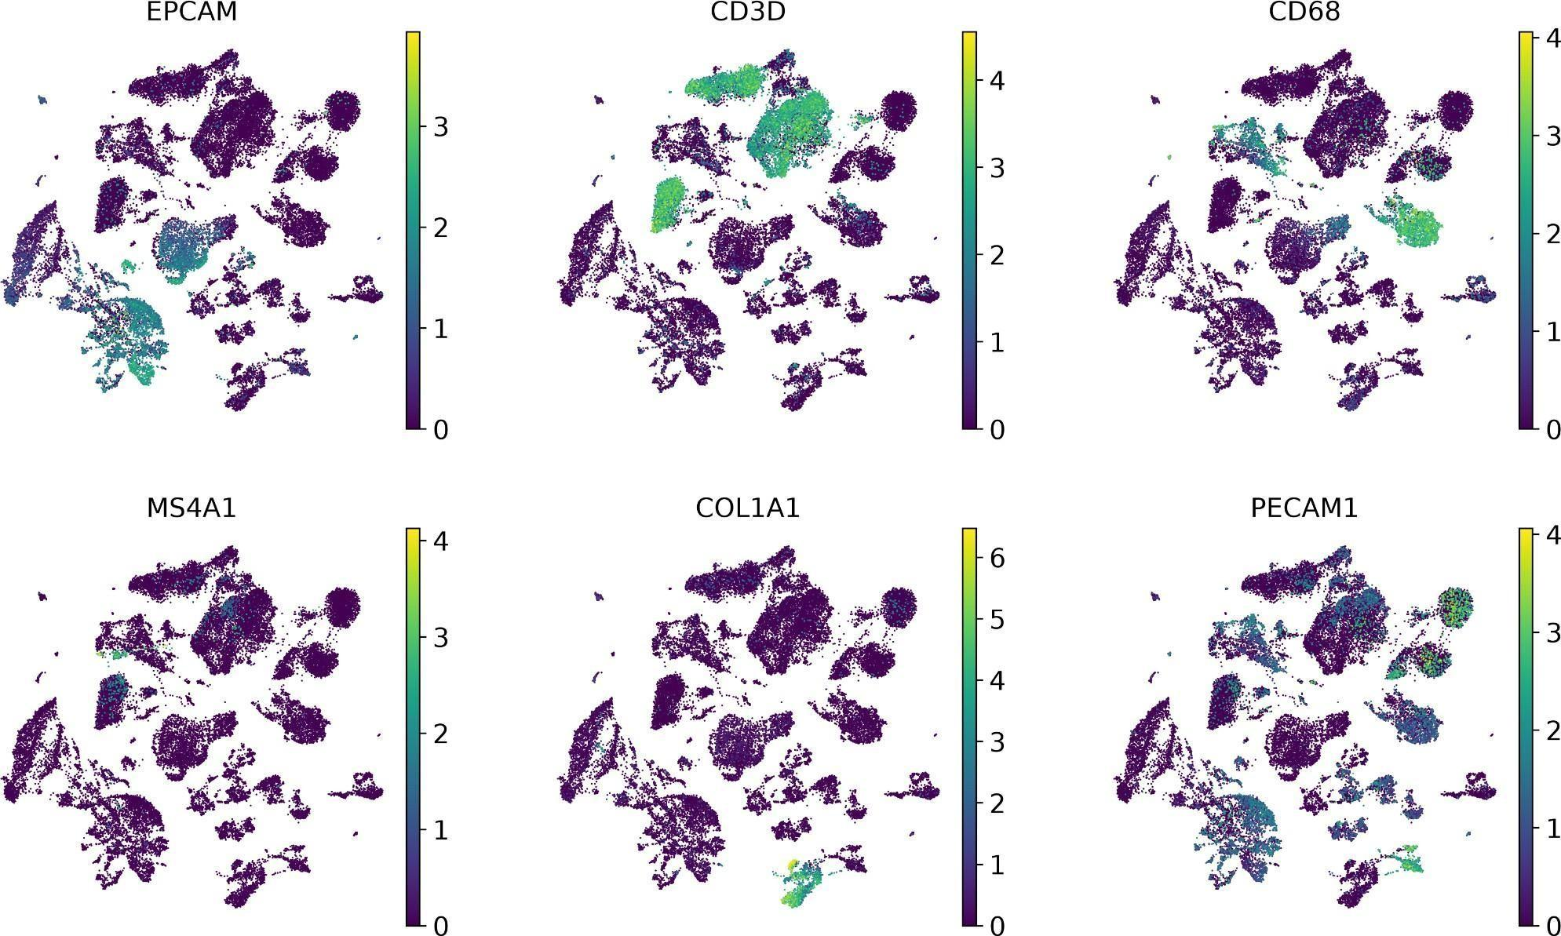

Figure 5b. UMAP feature plots of one representative marker per major lineage (EPCAM – epithelial/tumor, CD3D – T cells, CD68 – myeloid/TAMs, MS4A1 – B cells, COL1A1 – fibroblasts, PECAM1 – endothelial cells), confirming spatially restricted and mutually exclusive expression patterns that validate cluster identity.

Stage-resolved Differential Gene Expression
One-vs-rest differential expression (Wilcoxon) was computed for each of the four clinically defined stages (Normal, HSIL, SCC, ADC). Table 4 lists the top-ranked marker genes per stage by test statistic. The Normal-cervix signature was dominated by immunoglobulin transcripts (IGHA1, IGLC3, IGLC2, IGKC) reflecting resident mucosal plasma cells, together with the antimicrobial/barrier genes SAA1 and SLPI and keratins KRT13/KRT14 – a profile consistent with the epithelial-homeostasis / anti-microbial signature (including the SAA1–FPR2 ligand–receptor axis) described for the normal cervix in Guo et al. [1]. The HSIL signature was led by SCGB3A1, a secretoglobin previously reported (with its receptor MARCO) as an anti-microbial interaction specific to HSIL tissue in the same reference [1], alongside MIF (also highlighted in [1] as enhanced upon HPV infection) and the mucin/secretory genes AGR2, MUC5B, TFF3. The SCC signature was dominated by type-I interferon-stimulated genes (IFI6, ISG15, MX1, IFI44L, GBP1, GBP5, STAT1), antigen-presentation transcripts (HLA-DRA, HLA-DRB1) and macrophage/TAM markers (APOE, SPP1) together with the pro-inflammatory chemokine CXCL8 – consistent with the interferon/antigen-presentation and TAM-polarization axes emphasized in both reference studies [1,2]. The ADC signature was distinct and dominated by immediate-early/stress-response transcription factors (FOS, JUNB, JUND, DUSP1, IER2) and the NK-inhibitory ligand HLA-E, alongside keratin KRT13.

Stage | Gene | log2FC | Adj. P | % cells expr.
Normal | IGHA1 | 2.45 | <1e-300 | 61.0%
 | IGLC3 | 3.39 | <1e-300 | 46.4%
 | SAA1 | 2.53 | <1e-300 | 37.7%
HSIL | SCGB3A1 | 3.45 | <1e-300 | 37.3%
 | SCGB2A1 | 2.30 | <1e-300 | 37.8%
 | TFF3 | 1.54 | <1e-300 | 46.1%
SCC | C15orf48 | 2.46 | <1e-300 | 49.6%
 | IFI6 | 1.76 | <1e-300 | 53.1%
 | STAT1 | 1.62 | <1e-300 | 56.1%
ADC | KRT13 | 1.46 | <1e-300 | 72.0%
 | DUSP1 | 1.13 | <1e-300 | 86.6%
 | JUNB | 0.94 | <1e-300 | 92.1%
Table 4. Representative top one-vs-rest differentially expressed genes per histological stage (Wilcoxon rank-sum test). log2FC = log2 fold-change vs. remaining cohort; Adj. P = Benjamini–Hochberg adjusted P-value; % cells expr. = percentage of cells in the stage with non-zero expression

Immune-checkpoint / T-cell Exhaustion Transcripts Escalate Toward Carcinoma
Because global T-cell exhaustion is the central finding of both reference atlases [1,2], six canonical immune-checkpoint/Treg transcripts (PDCD1, CTLA4, HAVCR2, LAG3, TIGIT, FOXP3) were examined across all cells at each stage and, more quantitatively, in the one-vs-rest differential expression results (Table 5). All five genes other than PDCD1 were significantly up-regulated in SCC relative to the rest of the cohort (log2FC 0.79–1.80; adjusted P down to 2.5×10 for HAVCR2), while the same panel was significantly down-regulated in both the Normal and HSIL groups (e.g. HAVCR2 log2FC = −0.94 in Normal and −1.06 in HSIL; CTLA4 log2FC = −1.65 in HSIL). The ADC group showed a partial, intermediate pattern (significant up-regulation of TIGIT and CTLA4, nominal up-regulation of PDCD1, but no significant change in HAVCR2/LAG3/FOXP3), plausibly reflecting its smaller sample size (n=7,548 cells, single patient). This monotonic escalation of the checkpoint/exhaustion module from Normal → HSIL → SCC mirrors, at the whole-tissue transcript level, the cell-resolved CD8⁺ exhaustion trajectory (naive → effector memory → exhausted) and the Treg/Th17–Treg/Th1-like imbalance reported by Guo et al. and Qu et al. [1,2], despite this project not performing dedicated T-cell sub-clustering.
123

Gene | Normal | HSIL | SCC | ADC
PDCD1 | +0.11 | −0.18 | −0.32 | +0.45
CTLA4 | −0.47 | −1.65 | +1.15 | +0.59
HAVCR2 | −0.94 | −1.06 | +1.80 | −0.17
LAG3 | −0.12 | −0.98 | +0.79 | +0.03
TIGIT | −0.61 | −0.76 | +0.83 | +0.91
FOXP3 | −0.52 | −0.63 | +0.98 | +0.23
Table 5. log2 fold-change (one-vs-rest) of six immune-checkpoint/exhaustion transcripts across the four histological stages. Bold values in SCC column indicate statistically significant up-regulation (adjusted P<0.05).

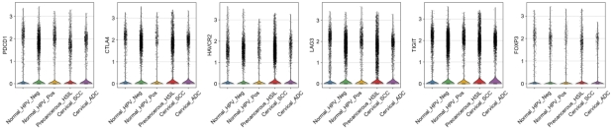
Figure 6. Expression of T-cell exhaustion and immune-checkpoint genes across the cervical neoplastic continuum.
Violin plots show normalized expression of PDCD1 (PD-1), CTLA4 (CTLA-4), HAVCR2 (TIM-3), LAG3 (LAG-3), TIGIT and FOXP3 in cells from Normal_HPV_Neg, Normal_HPV_Pos, Precancerous_HSIL, Cervical_SCC and Cervical_ADC samples. The majority of cells exhibit low expression, while a subset of cells in every stage displays elevated levels of these markers. The presence of PDCD1, CTLA4, HAVCR2, LAG3 and TIGIT indicates a population of T cells with an exhaustion phenotype, and FOXP3 expression is consistent with regulatory T cells. These findings support the existence of an immunosuppressive microenvironment throughout HPV-driven cervical neoplasia.

Genes displayed
Tabel 6: Six well-established markers of T-cell exhaustion and regulatory activity:
Gene | Protein | Role in immunity
PDCD1 | PD-1 | Inhibitory receptor; hallmark of T-cell exhaustion
CTLA4 | CTLA-4 | Inhibitory receptor; highly expressed on Tregs & exhausted T cells
HAVCR2 | TIM-3 | Marks terminally exhausted T cells
LAG3 | LAG-3 | Co-inhibitory receptor contributing to T-cell dysfunction
TIGIT | TIGIT | Co-inhibitory receptor often co-expressed with PD-1
FOXP3 | FOXP3 | Master transcription factor of regulatory T cells (Tregs)

Pathway Enrichment Reveals Stage-specific Functional Programs
Applying a log2FC>1 / adjusted P<0.01 threshold to each stage’s one-vs-rest DE results yielded 521 significantly up-regulated genes in Normal, 1,131 in HSIL, 665 in SCC and only 49 in ADC (the smaller ADC gene set, and its correspondingly weaker enrichment statistics – best adjusted P≈0.049 – is again attributable to its single-patient, smaller-n composition). Over-representation analysis showed clearly non-overlapping, biologically coherent programs per stage: the Normal cervix signature was enriched for extracellular-matrix organization, focal adhesion, PI3K-Akt signaling and regulation
of angiogenesis – a stromal/epithelial-homeostasis signature; the HSIL signature was enriched for cilium assembly/organization and plasma-membrane projection assembly, together with DNA-repair-related terms (Fanconi anemia pathway, homologous recombination) – consistent with the genomic-instability phenotype expected at the precancerous stage; the SCC signature was overwhelmingly immune/inflammatory (Reactome Immune System, GO Inflammatory Response, cytokine signaling, and – notably – negative regulation of T-cell proliferation, directly consistent with the T-cell exhaustion/suppression theme of Table 3 and of references [1,2]); and the ADC signature, despite its small gene set, was dominated by granulocyte/neutrophil chemotaxis and migration terms. One HSIL-associated KEGG term (“Maturity onset diabetes of the young”) reflects overlap with a shared transcription-factor gene set (HNF4A/HNF4G/HNF1B/FOXA2/FOXA3) rather than a biologically meaningful diabetes association, and is flagged here as a caveat of naive over-representation testing on generic pathway databases (Section 5).

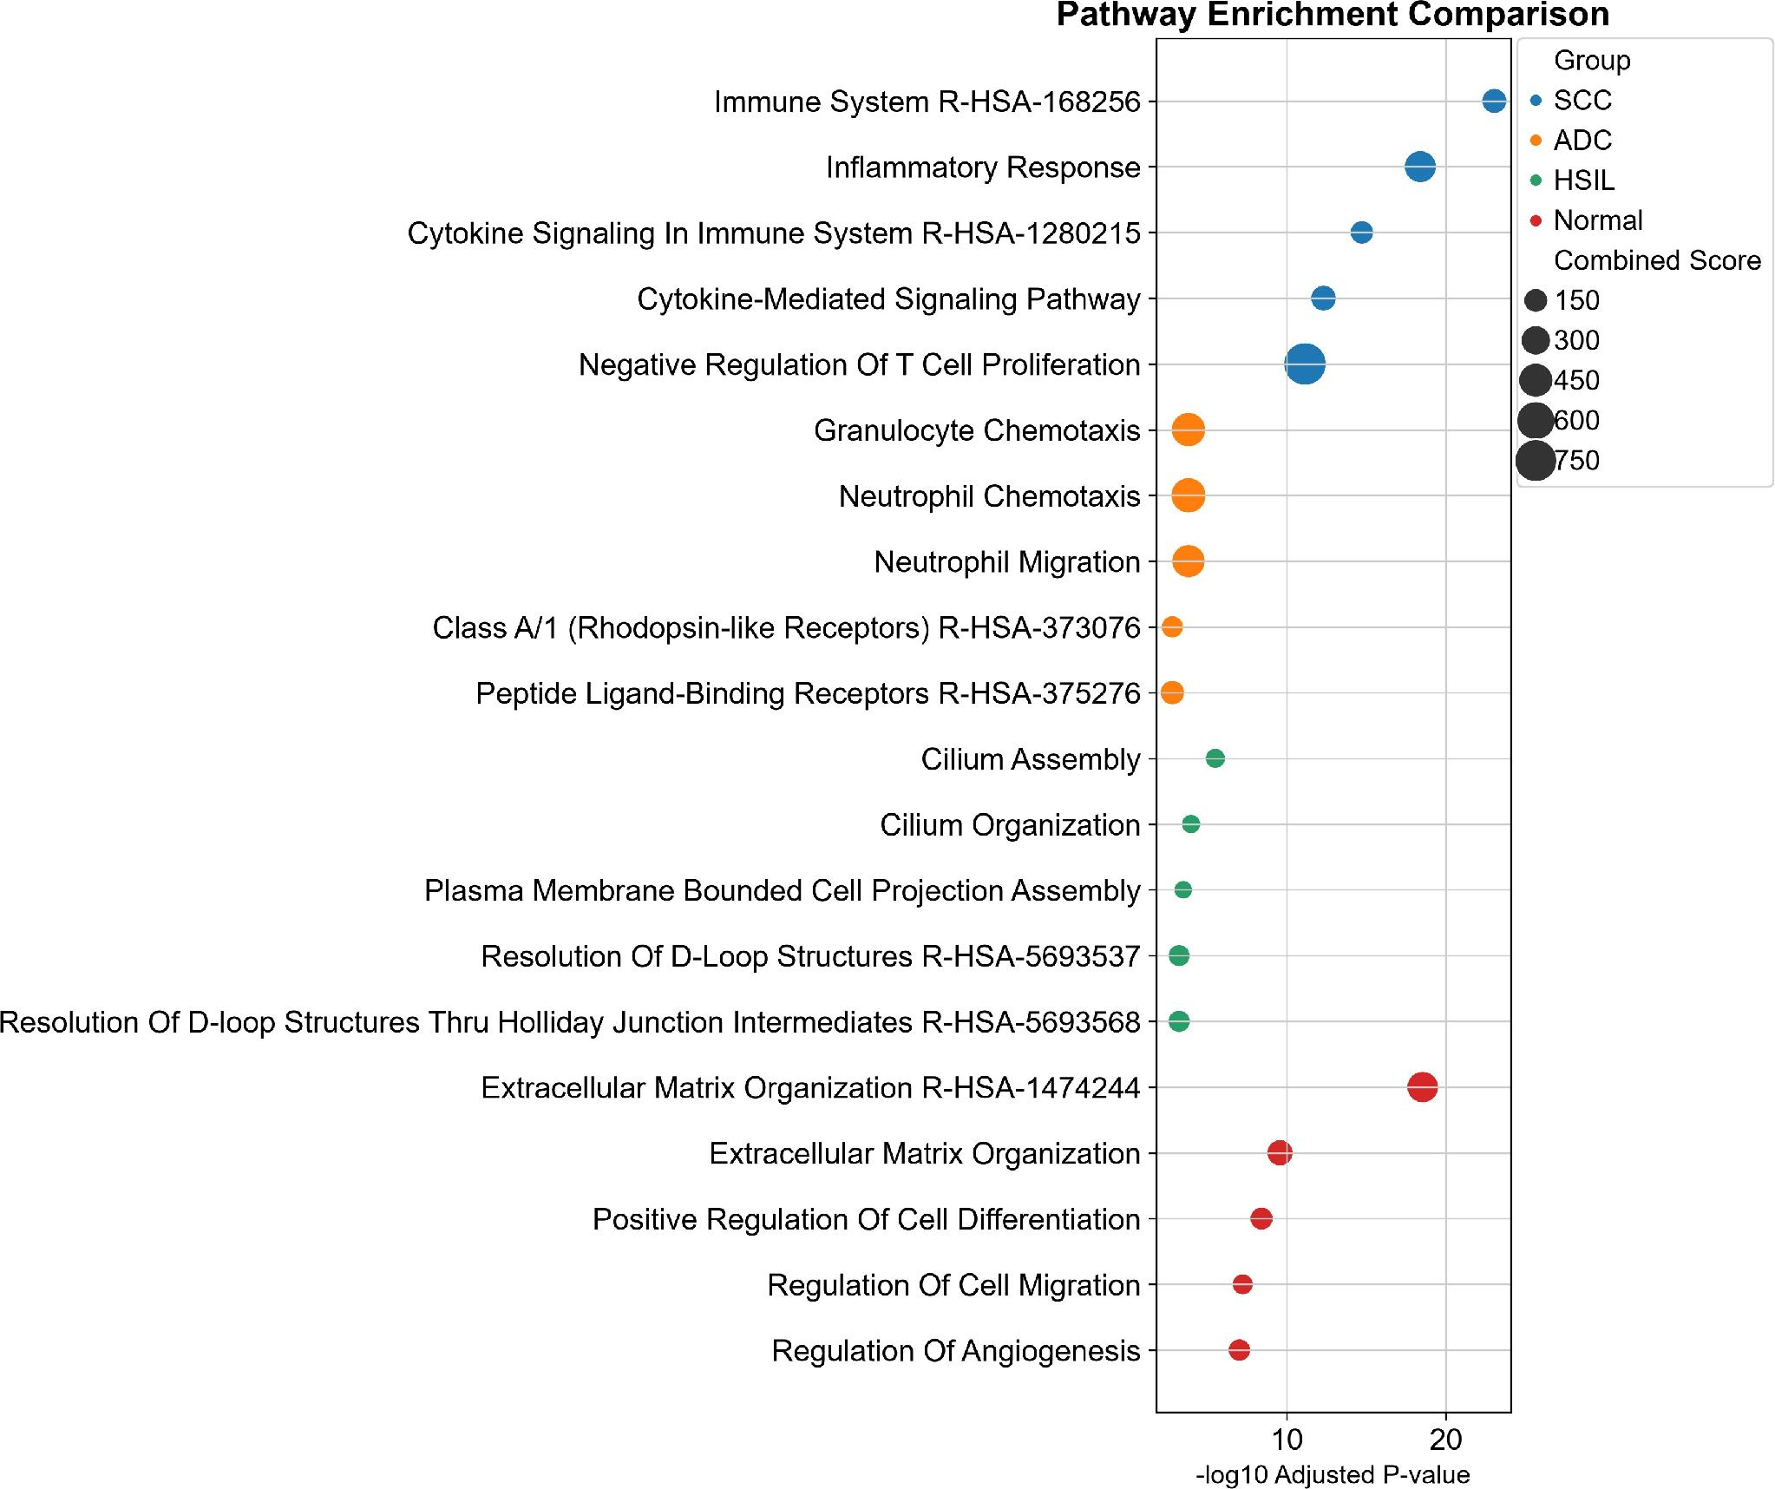
Figure 7. Stage-specific pathway enrichment analysis reveals progressive remodeling of the cervical tumor microenvironment.
Bubble plot showing significantly enriched biological pathways across normal cervix, high-grade squamous intraepithelial lesion (HSIL), cervical squamous cell carcinoma (SCC), and cervical adenocarcinoma (ADC). The x-axis represents pathway significance as −log10(adjusted P-value), with larger values indicating stronger enrichment. Bubble size corresponds to the combined enrichment score, and colors indicate clinical groups. Normal cervical tissues showed enrichment of extracellular matrix organization, cell differentiation, migration, and angiogenesis-related pathways, reflecting tissue homeostasis. HSIL samples demonstrated enrichment of DNA repair and cellular structural organization pathways, indicating early molecular alterations during malignant transformation. SCC samples exhibited strong activation of immune system pathways, cytokine-mediated signaling, and negative regulation of T-cell proliferation, suggesting immune infiltration accompanied by immunosuppressive remodeling. ADC samples displayed enrichment of granulocyte chemotaxis, neutrophil migration, and inflammatory signaling pathways, indicating a distinct immune recruitment pattern. Overall, the analysis demonstrates progressive transition from normal tissue maintenance toward immune-modulated and inflammatory tumor microenvironments during cervical carcinogenesis.

Stage | Database | Top term | Adj. P
Normal | Reactome 2022 | Extracellular Matrix Organization R-HSA-1474244 | 2.93e-19
 | GO BP 2023 | Extracellular Matrix Organization (GO:0030198) | 2.64e-10
HSIL | GO BP 2023 | Cilium Assembly (GO:0060271) | 3.01e-06
 | GO BP 2023 | Cilium Organization (GO:0044782) | 1.01e-04
SCC | Reactome 2022 | Immune System R-HSA-168256 | 9.30e-24
 | GO BP 2023 | Inflammatory Response (GO:0006954) | 4.11e-19
ADC | GO BP 2023 | Neutrophil Migration (GO:1990266) | 1.46e-04
 | GO BP 2023 | Granulocyte Chemotaxis (GO:0071621) | 1.46e-04

Table 7. Top enriched terms per stage across combined KEGG/GO-BP/Reactome libraries, ranked by Benjamini–Hochberg adjusted P-value.

Discussion
This independent, entry-level re-analysis of nine 10x Genomics cervical samples recovers, at coarse transcript-frequency resolution, several of the central conclusions of the two reference atlases used to design this project. First, the top marker genes identified for the Normal and HSIL groups directly overlap with ligand–receptor pairs and cluster markers reported by Guo et al. – notably SAA1 (Normal; part of the SAA1–FPR2 axis implicated in normal epithelial immune-surveillance [1]), SCGB3A1 and MIF (HSIL; both flagged in [1] as HPV-infection/HSIL-specific signalling) – despite this project using a wholly independent clustering and DE pipeline. Second, and more centrally, the escalating immune-checkpoint/exhaustion signature observed here (Table 5: HAVCR2, TIGIT, LAG3, CTLA4, FOXP3 all significantly elevated specifically in SCC) is fully consistent with the CD8⁺ T-cell exhaustion trajectory (Tn → Tem/TemRA → Tex, marked by HAVCR2, CXCL13, PDCD1, CTLA4) and the Treg expansion (Treg/Th17 and Treg/Th1-like imbalance) that Guo et al. and Qu et al. describe using dedicated T-cell sub-clustering and TCR-seq clonotype analysis [1,2]. That this signal is recoverable from a simple one-vs-rest, whole-tissue differential expression test – without isolating T cells first – suggests the checkpoint/exhaustion shift in cervical carcinoma is large enough in magnitude and cell-fraction to be detectable even at reduced analytical resolution, which has practical value for rapid triage of new datasets.
Third, the pathway-level results reinforce this same narrative from an orthogonal angle: the Normal cervix program (ECM organization, focal adhesion, angiogenesis regulation) matches an epithelial/stromal-homeostasis state, while the SCC program (Reactome Immune System, Inflammatory Response, cytokine signaling, and explicitly “negative regulation of T-cell proliferation”) matches the immune-suppressive, cytokine-driven microenvironment that both reference papers attribute to macrophage M1→M2 polarization (via PPAR/IL-10/HIF-1α signaling) and to the LAMP3⁺ DC–IDO1–tryptophan axis described by Qu et al. [2]. Although the present pipeline did not sub-cluster myeloid cells or run CellPhoneDB, several SCC top-DE genes (APOE, SPP1, both TAM/M2 markers, and HLA-DR antigen-presentation genes) are directionally consistent with this mechanism, and the interferon-stimulated-gene module (ISG15, MX1, IFI44L, GBP1/5, STAT1) recovered here is compatible with the tryptophan/kynurenine–aryl-hydrocarbon-receptor and type-I IFN cross-talk that both papers implicate in remodeling the myeloid compartment. The ADC-specific, immediate-early/stress-response signature (FOS/JUN family) and the NK-inhibitory ligand HLA-E are novel observations relative to the two reference papers (which pooled or under-sampled ADC) and merit follow-up in a larger adenocarcinoma cohort.
Overall, the concordance between this independent, simplified pipeline and two peer-reviewed reference atlases – despite substantial methodological differences (no spatial transcriptomics, no CellPhoneDB, no TCR-seq, no dedicated T-cell/myeloid sub-clustering, and a >4× smaller sample than reference [2]) – provides reassuring internal validation of both the underlying biology (progressive immune exhaustion accompanying HPV-driven carcinogenesis) and of the correctness of the implemented Scanpy/GSEApy workflow.

Limitations
The ADC group comprised a single patient (ADC_6, 7,548 cells); its differential-expression and enrichment results should be treated as descriptive rather than generalizable, and several nominally significant ADC findings did not survive multiple-testing correction as robustly as SCC or Normal. Batch/sample-of-origin effects were not explicitly corrected (no Harmony/scVI/BBKNN integration); some residual inter-sample structure is visible within the epithelial compartment of the UMAP (Figure 4, bottom right), which could inflate apparent stage-specific epithelial heterogeneity.
Immune-checkpoint/exhaustion transcripts (Table 5) were quantified across the whole cell population rather than within a dedicated, sub-clustered T-cell compartment; the reported log2 fold-changes therefore reflect a mixture of per-cell
up-regulation and a shift in the relative abundance of checkpoint-high cell states, which cannot be disentangled without the CD8⁺/CD4⁺ re-clustering performed in the reference papers [1,2]. Regulatory T cells, dendritic-cell subsets (including the IDO1⁺ LAMP3⁺ population central to reference [2]) and tumor-associated macrophage polarization states were not resolved at the current Leiden resolution (0.8) and marker-panel granularity; a second round of lineage-restricted sub-clustering, CNV inference (inferCNV) to confirm epithelial malignancy, and ligand–receptor analysis (e.g., CellPhoneDB) would be required to directly test the DC–Treg–Tex immunosuppressive circuit proposed in [2]. Over-representation analysis against generic KEGG/GO/Reactome libraries is susceptible to spurious enrichment driven by shared transcription-factor or receptor-family gene sets (e.g., the HSIL “Maturity onset diabetes of the young” term, driven by shared HNF/FOXA transcription factors rather than a metabolic phenotype) and should be interpreted alongside the underlying gene lists rather than term names alone.

Conclusion
A standard Scanpy-based scRNA-seq workflow applied to nine publicly available cervical tissue samples reconstructs a normal–HSIL–carcinoma continuum in which immune-checkpoint and exhaustion-associated transcripts (HAVCR2, TIGIT, LAG3, CTLA4, FOXP3) become significantly and specifically enriched in squamous cell carcinoma, while extracellular-matrix/homeostasis programs dominate the normal cervix and DNA-repair/ciliary programs mark the HSIL precancerous stage. These findings independently corroborate the immune-remodeling narrative described by Guo et al. [1] and Qu et al. [2] using more extensive single-cell, spatial and functional validation. The processed data, differential-expression tables, enrichment tables and all figures used in this report are version-controlled in the accompanying repository (Milestone 1 deliverable: tag v1.0-peerreview) to support peer review and future extension – in particular, T-cell and myeloid sub-clustering, CNV-based malignancy confirmation, and ligand–receptor analysis of the dendritic-cell–T-cell immunosuppressive circuit – in the Milestone 2/3 revision cycle.

References
- Guo C, Qu X, Tang X, Song Y, Wang J, Hua K, Qiu J. Spatiotemporally deciphering the mysterious mechanism of persistent HPV-induced malignant transition and immune remodelling from HPV-infected normal cervix, precancer to cervical cancer: Integrating single-cell RNA-sequencing and spatial transcriptome. Clin Transl Med. 2023;13(3):e1219. doi:10.1002/ctm2.1219.
- Qu X, Wang Y, Jiang Q, Ren T, Guo C, Hua K, Qiu J. Interactions of Indoleamine 2,3-dioxygenase-expressing LAMP3⁺ dendritic cells with CD4⁺ regulatory T cells and CD8⁺ exhausted T cells: synergistically remodeling of the immunosuppressive microenvironment in cervical cancer and therapeutic implications. Cancer Commun. 2023;43(11):1207–1228. doi:10.1002/cac2.12486.
- Sung H, Ferlay J, Siegel RL, et al. Global cancer statistics 2020: GLOBOCAN estimates of incidence and mortality worldwide for 36 cancers in 185 countries. CA Cancer J Clin. 2021;71(3):209–249.
- Wolf FA, Angerer P, Theis FJ. SCANPY: large-scale single-cell gene expression data analysis. Genome Biol. 2018;19:15.
- Traag VA, Waltman L, van Eck NJ. From Louvain to Leiden: guaranteeing well-connected communities. Sci Rep. 2019;9:5233.
- Chen EY, Tan CM, Kou Y, et al. Enrichr: interactive and collaborative HTML5 gene list enrichment analysis tool. BMC Bioinformatics. 2013;14:128; Xie Z, et al. Gene set knowledge discovery with Enrichr. Curr Protoc. 2021;1:e90 (GSEApy implementation).
- Becht E, McInnes L, Healy J, et al. Dimensionality reduction for visualizing single-cell data using UMAP. Nat Biotechnol. 2019;37:38–44.

Declaration of AI Tool Usage
Single-cell RNA-seq Analysis of the Cervical Tumor Microenvironment

AI Tools Used and Their Roles

AI Tool | Provider / Version | Purpose / Tasks Performed
ChatGPT Plus | OpenAI (GPT-4o / GPT-4) | • Literature understanding and paper summarization  • Code explanation and debugging assistance  • Drafting and refinement of methodology text  • Review of scientific concepts related to scRNA-seq and cancer immunology
Gemini | Google (Gemini Advanced / 1.5 Pro) | • Literature search support and paper comprehension  • Cross-checking of biological concepts (HPV, TME, exhaustion)  • Assistance with code logic and alternative approaches  • Review and clarification of analytical workflows
Claude | Anthropic (Claude 3.5 / Claude 4) | • Critical review of methodology and interpretation drafts  • Refinement of scientific language and structure  • Assistance with logical flow of results and discussion points  • Code review and suggestion of best practices

Summary of AI Assistance by Project Stage

Project Stage | AI Tools Involved & Contribution
Project analysis & planning | ChatGPT Plus, Gemini, Grok – understanding overall scRNA-seq workflow and cervical cancer biology
Paper understanding & review | ChatGPT Plus, Gemini, Claude – summarization of published scRNA-seq and HPV/cervical cancer papers
Code editing & debugging | ChatGPT Plus, Claude, Gemini – assistance with Scanpy code, QC metrics, rank_genes_groups, and plotting
Methodology description | Grok, ChatGPT Plus, Claude – structured, passive-voice methods sections for QC, filtering, exhaustion analysis, and DE
Results interpretation | Grok (primary), ChatGPT Plus, Claude – biological interpretation of QC plots, marker dot plots, and T-cell exhaustion violins; manuscript-ready figure legends

Author Responsibility Statement
The author critically reviewed, verified, and edited all AI-generated suggestions, text drafts, and code recommendations. Final decisions regarding experimental design, data analysis parameters, biological interpretation, and conclusions were made solely by the author. The AI tools served only as assistive instruments and do not share authorship.
This declaration is provided in the interest of transparency and research integrity.
Author Contribution
Project Title: Single-cell RNA Sequencing Analysis of Cervical Cancer Tumor Microenvironment Remodeling
Author Name | Contribution Details
Dr. Sumaya Khan Mifty | • Research paper analysis and literature review  • Preparation of Abstract and Introduction sections  • Description of Methodology: Pathway Enrichment Analysis using GSEApy  • Interpretation and explanation of figures:  - ORA pathway comparison  - Highly variable genes (highly_variable_genes_colore)  - PCA variance ratio (pca_variance_ratio)
Jerin Shubah Lamia | • Research paper analysis  • Methodology section description:  - Data Retrieval and Sample Composition  - Dimensionality Reduction and Graph-Based Clustering  - Tumor Microenvironment Cell Type Annotation  • Interpretation and explanation of figures:  - UMAP embeddings showing clusters and tissue group distribution  - Cell lineage dotplot/feature plots establishing cell-type identities
Sayma Anjum Sujana | • Research paper analysis  • Methodology section description:  - Quality Control (QC) and Filtering  - Evaluation of T-cell Exhaustion and Immune Checkpoint Expression  - Differential Gene Expression Analysis  • Interpretation and explanation of figures:  - Quality Control (QC) Metrics – Violin Plots  - T-cell Exhaustion and Immune Checkpoint Gene Expression
All authors contributed to research paper analysis and collaborated in the development, interpretation, and documentation of the single-cell RNA sequencing project.

